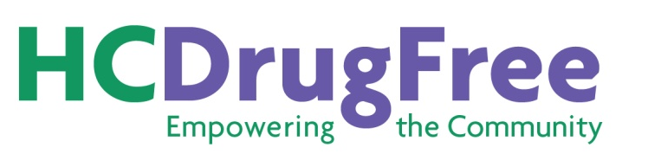
Please Support HC DrugFree

Please become a Friend of HC DrugFree for the current year. As a Friend of HC DrugFree,
your name will appear on our website and you will receive timely updates about HC DrugFree programs and events, and updates on laws related to underage drinking and drug use.

Yes, I would like to become a Friend of HC DrugFree:

$10 - Student $100 - Business
$25 - Individual Other __________________________________
$50 - Family or Nonprofit Organization

Name to appear on website: ________________________________________________________

If you would like your name to appear on our website “in memory of” or “in honor of” a loved one, please add his/her name here:
In memory of: __________________________________________________________________
In honor of: ____________________________________________________________________

Or maybe you would like to become a Sponsor of HC DrugFree…
Benefits of Sponsorship Include:

►Name listed by Sponsorship Level on the HC DrugFree website at www.hcdrugfree.org
►Name listed as a Friend of HC DrugFree on the HC DrugFree website

Yes, I would like to become a Sponsor of HC DrugFree:

$500 - Bronze Sponsor $5,000 - Platinum Sponsor
$1,000 - Silver Sponsor $10,000 - Diamond Sponsor
$2,500 - Gold Sponsor Other ___________________________________

Name to appear on website: _________________________________________________________

Make your tax-deductible donation check payable to: HC DrugFree Inc. and mail to
HC DrugFree, Wilde Lake Village Center, 5305 Village Center Drive, Suite 206, Columbia, MD 21044

Name: ___________________________________________Email Address: _________________________________

Street Address: __________________________________________________________________________________

City: ____________________________________________________State:___________________________________

Phone: ________________________________ Website: _________________________________________________

Thank you for your support.

